**ISCSI RAID CONF Installation**

**Required Machines**

**Server : 1GB RAM, 20 GB x 4 HDD, NAT**

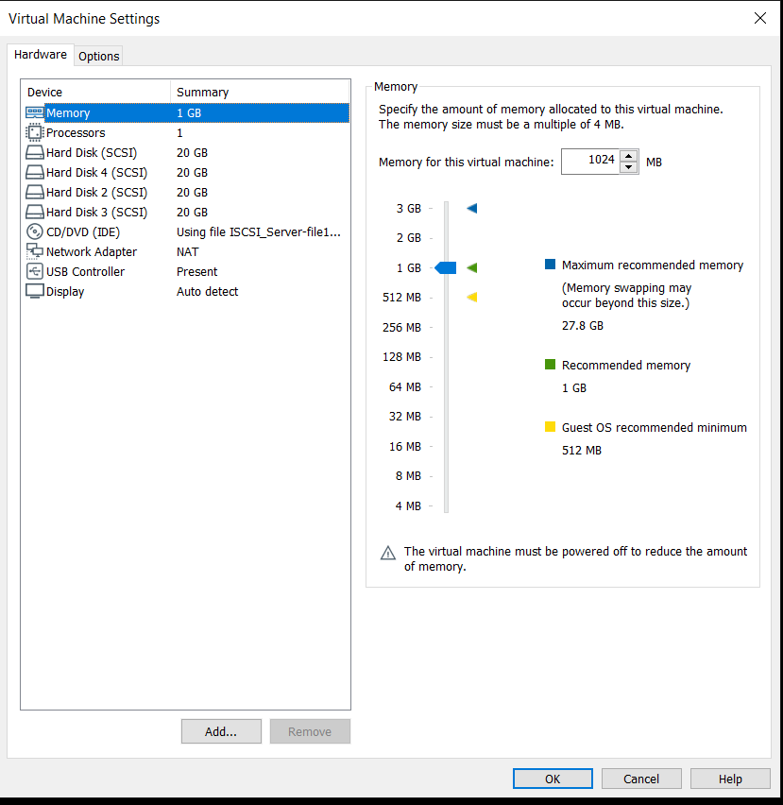

**Client : 1GB RAM, 20 GB HDD**

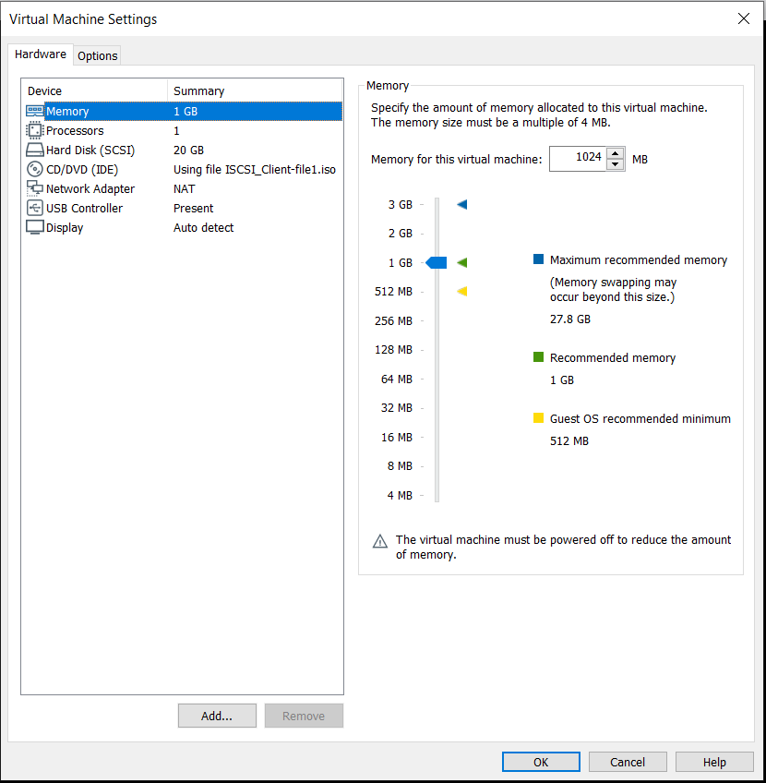

**ON Server :-**

**# pvcreate /dev/sdb /dev/sdc /dev/sdd**

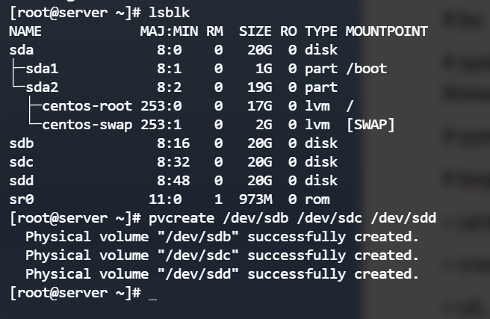

**# vgcreate vg-iscsi /dev/sdb /dev/sdc /dev/sdd**

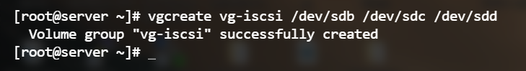

**# lvcreate –n lv_iscsi-disk-01 -L 1G vg-iscsi**

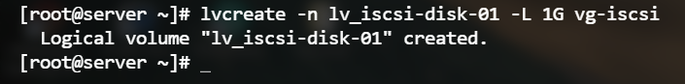

**# lvcreate –n lv_iscsi-disk-02 -L 1G vg-iscsi**

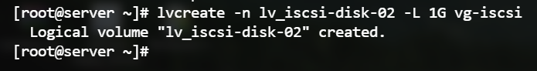

**# lvs**

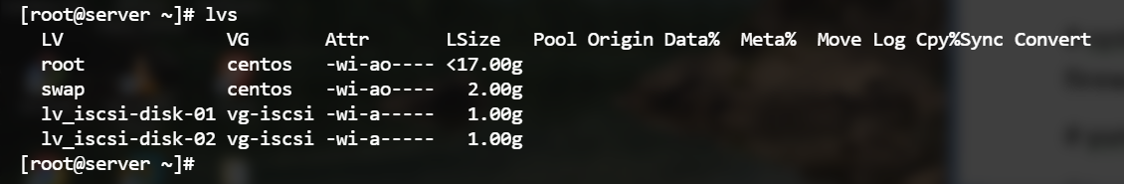

**# systemctl stop firewalld && systemctl disable firewalld && systemctl status firewalld**

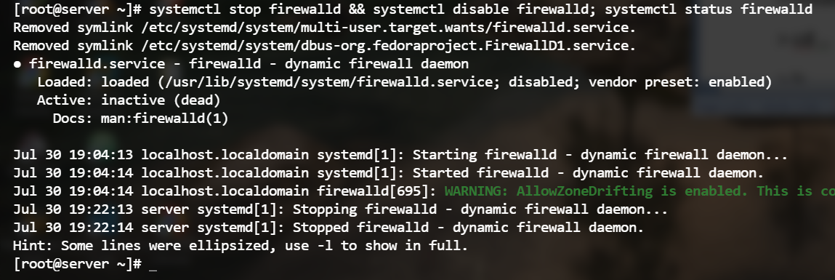

**# yum install targetcli**

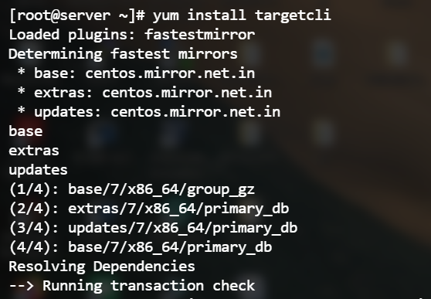

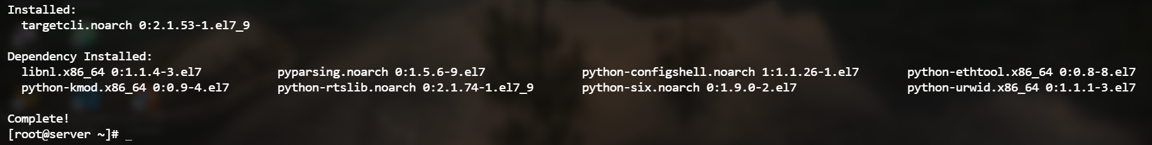

**# targetcli -------------> (**now you get new command line shell)

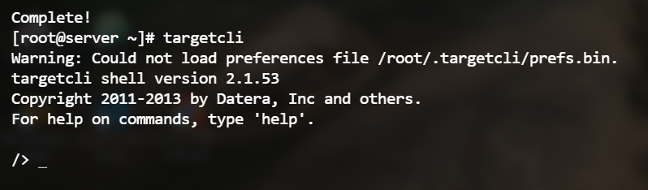

**> cd backstores/block**

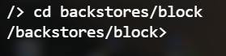

**> create block /dev/mapper/vg--iscsi-lv_iscsi--disk--01**

**> cd ..**

**> ls**

**> cd ..**

**> cd iscsi**

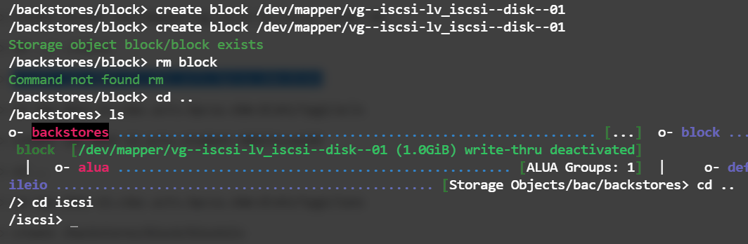

**> create iqn.2023-07.cdac.acts.hpcsa.sbm:disk1**

**> cd iqn.2023-07.cdac.acts.hpcsa.sbm:disk1/**

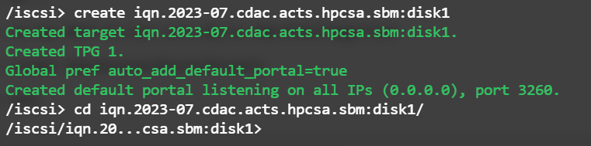

**ON Client**

**# yum install iscsi-initiator-utils –y**

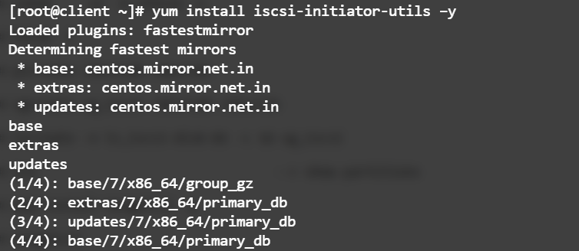

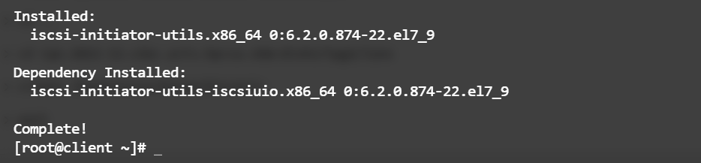

**# systemctl stop firewalld && systemctl disable firewalld && systemctl status firewalld**

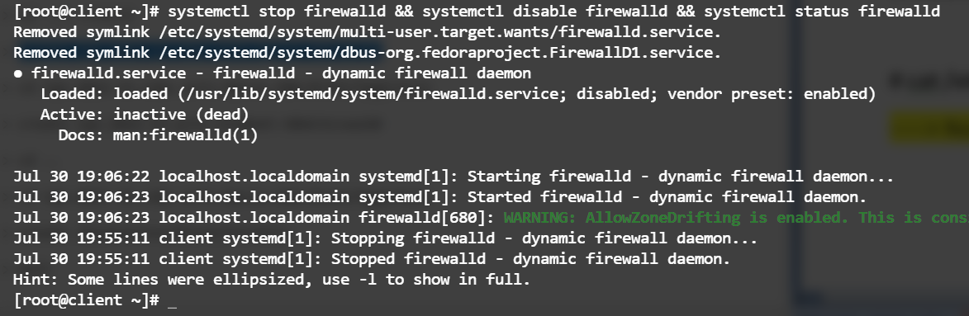

**# cat /etc/iscsi/initiatorname.iscsi**

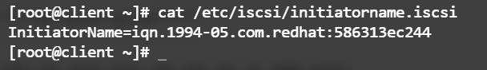

-----> Now copy initiator Name

**ON Server**

**> cd tpg1/acls**

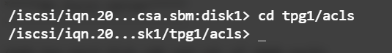

**> create initiator name (Paste the initiator name which is copied from client)**



**> cd ..**

**> cd luns**

**> create /backstores/block/block**

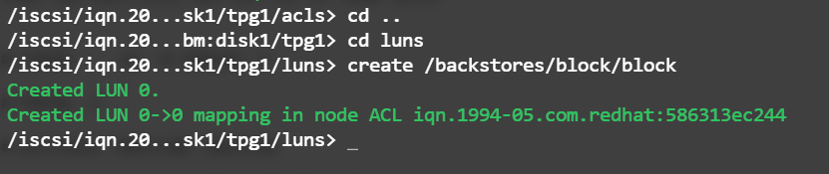

**> ls**

**> exit**

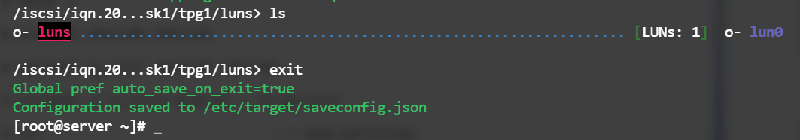

**# systemctl restart target**

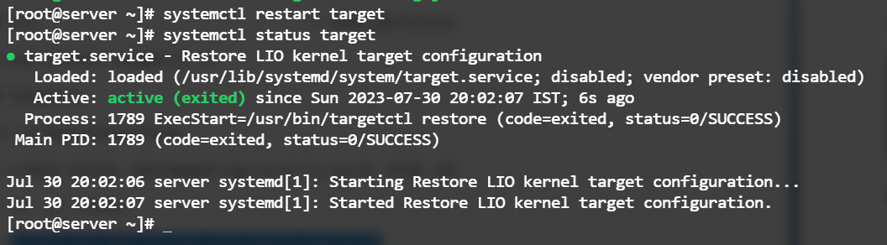

**ON Client**

**# iscsiadm -m discovery -t st -p <Server_ip> --login**

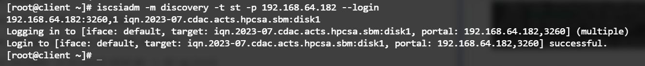

**# fdisk /dev/sdb**

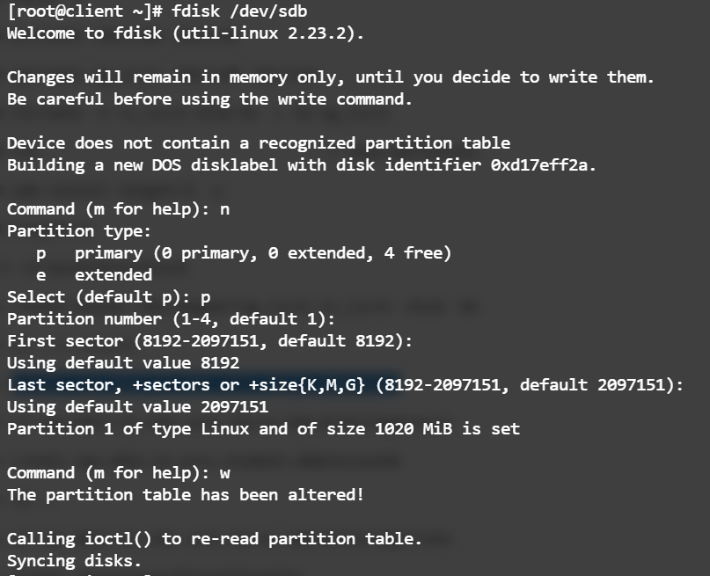

**# mkfs.ext4 /dev/sdb1**

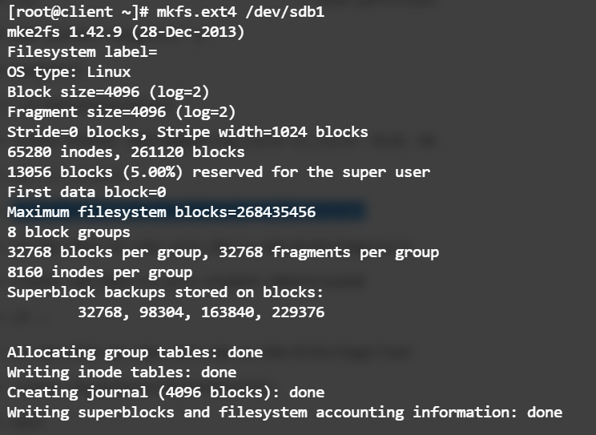

**# mkdir /mnt/iscsilab**

**# mount /dev/sdb1 /mnt/iscsilab**

**# cd /mnt/iscsilab/**

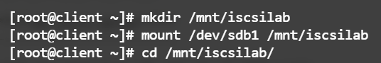

**# dd if=/dev/zero of=file.txt bs=1024 count=1024**

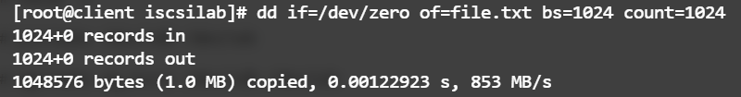

**# df –h**

